STOCK

MANAGER

v1.0

By: Harguna Sood

(101510028)

(CML-2)

**E-R DIAGRAM**

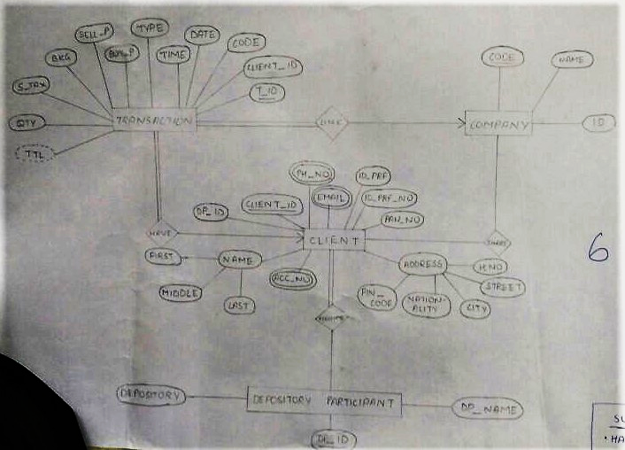

The design of database system is as such that it enables a **stock broker** to make transactions for his/her **client**. The **stock broker** can have zero or more **clients**. Each **client** can have one or more **transactions** but each **transaction** can be made by only one **client**. Each **client** is further associated with one or more **depository**(ies) and each **depository** can have zero or more **clients**. **Transactions** are made of shares which belong to a **company**. Each **company** has its own share. Each **company** can give its share to zero or more **clients** and each **client** can have shares of zero or more **companies**. Also, each **transaction** can have only one **company**’s share but each **company** can be in zero or more **transactions**.

**E-R DIAGRAM 🡪 TABLE**

**CONVERSION**

**Rule:1**

|  |  |  |  |  |  |  |  |  |  |  |  |
| --- | --- | --- | --- | --- | --- | --- | --- | --- | --- | --- | --- |
| T_id | Client_id | Code | Date | Time | Type | Buy_p | Sell_p | Bkg | S_tax | Qty | Ttl |
|  |  |  |  |  |  |  |  |  |  |  |  |

Create separate table for each entity set

**TRANSACTION:**

|  |  |  |  |  |  |  |  |  |  |
| --- | --- | --- | --- | --- | --- | --- | --- | --- | --- |
| Client_id | Name | Ph_no | Email | Address | Id_prf | Id_prf_no | Pan_no | Acc_no | Dp_id |
|  |  |  |  |  |  |  |  |  |  |

**CLIENT:**

**COMPANY:**

|  |  |  |
| --- | --- | --- |
| Code | C_name | Id |
|  |  |  |

**DP:**

|  |  |  |
| --- | --- | --- |
| Dp_id | Dp_name | Depository |
|  |  |  |

**Rule:2**

In case of composite attribute, create column for branches and ignore the root.

**CLIENT:**

|  |  |  |  |  |  |  |
| --- | --- | --- | --- | --- | --- | --- |
| Client_id | First_name | Middle_name | Last_name | Pin_code | Nationality | City |
|  |  |  |  |  |  |  |

|  |  |  |  |  |  |  |  |  |
| --- | --- | --- | --- | --- | --- | --- | --- | --- |
| Street | H_no | Ph_no | Email | Id_prf | Id_prf_no | Pan_no | Acc_no | Dp_id |
|  |  |  |  |  |  |  |  |  |

**Rule:3**

No column for derived attribute

**TRANSACTION**

|  |  |  |  |  |  |  |  |  |  |  |
| --- | --- | --- | --- | --- | --- | --- | --- | --- | --- | --- |
| T_id | Client_id | Code | Date | Time | Type | Buy_p | Sell_p | Bkg | S_tax | Qty |
|  |  |  |  |  |  |  |  |  |  |  |

**Rule:4**

For every multi-valued attribute, create new table

**CLIENT:**

|  |  |  |  |  |  |  |
| --- | --- | --- | --- | --- | --- | --- |
| Client_id | First_name | Middle_name | Last_name | Pin_code | Nationality | City |
|  |  |  |  |  |  |  |

|  |  |  |  |  |  |
| --- | --- | --- | --- | --- | --- |
| Street | H_no | Id_prf | Id_prf_no | Pan_no | Dp_id |
|  |  |  |  |  |  |

**ACCOUNT:**

|  |  |
| --- | --- |
| Client_id | Acc_no |
|  |  |

**PHONE:**

|  |  |
| --- | --- |
| Client_id | Ph_no |
|  |  |

**EMAIL_ID:**

|  |  |
| --- | --- |
| Client_id | Email |
|  |  |

Now, for **many to one relations**, (i.e. Transacion-Client, Transaction-Company) copy the pk of ‘one’ to ‘many’ side i.e. ‘client_id’ and ‘code’ to Transaction, which is already there.

Now, for **many to many relations,** i.e.(Client-Company, Client-DP), create a new table:

|  |  |
| --- | --- |
| Client_id | Code |
|  |  |

|  |  |
| --- | --- |
| Client_id | DP_id |
|  |  |

So, after conversion, we have following tables:

TRANSACTION, CLIENT, ACCOUNT, PHONE, EMAIL, DP, COMPANY, (Client_id, Code), (Client_id, DP_id)

**NORMALIZATION**

**TRANSACTION**

|  |  |  |  |  |  |  |  |  |  |  |
| --- | --- | --- | --- | --- | --- | --- | --- | --- | --- | --- |
| T_id | Client_id | Code | Date | Time | Type | Buy_p | Sell_p | Bkg | S_tax | Qty |
|  |  |  |  |  |  |  |  |  |  |  |

First N/F: It is already in first n/f as each row and column combination will have at least one value.

Second N/F:

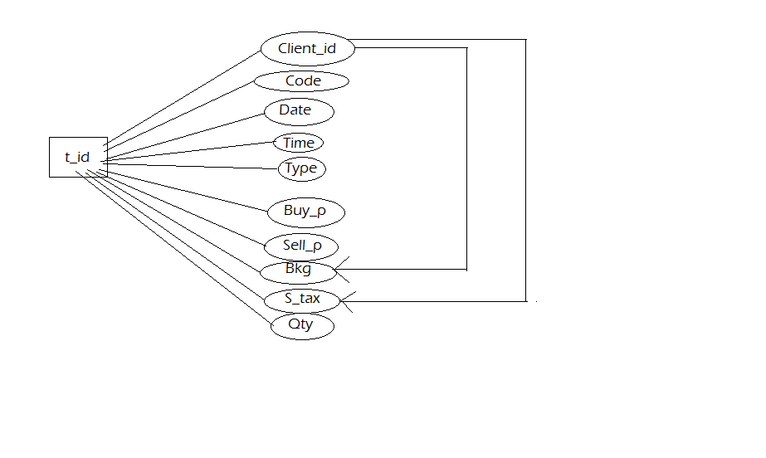

It is already in first n/f and ‘t_id’ functionally determines all other non-key attributes. Thus, it is in second n/f.

Third N/F:

It is already in second n/f but there is a transitive edge. Thus, it is not in third n/f

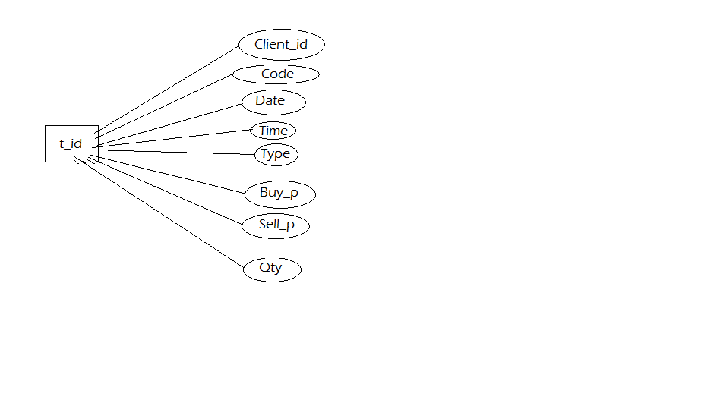 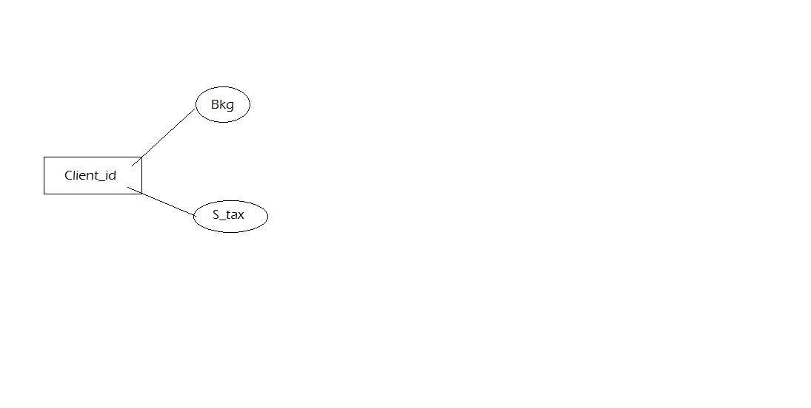

Now, there is not transitive edge and in new table client_id functionally determines bkg and s_tax, thus, it is in third n/f.

**Tax:**

|  |  |  |
| --- | --- | --- |
| Client_id | Bkg | S_tax |
|  |  |  |

BC N/F: It satisfies bc n/f as no non-key attribute functionally determines ‘t_id’.

Fourth N/F:

It is already in third n/f and there is no multi value dependency, thus, it is in fourth n/f.

Fifth N/F:

It is in fourth n/f abd can’t be decomposed any further into smaller tables, thus, is in fifth n/f.

**CLIENT:**

|  |  |  |  |  |  |  |
| --- | --- | --- | --- | --- | --- | --- |
| Client_id | First_name | Middle_name | Last_name | Pin_code | Nationality | City |
|  |  |  |  |  |  |  |

|  |  |  |  |  |  |
| --- | --- | --- | --- | --- | --- |
| Street | H_no | Id_prf | Id_prf_no | Pan_no | Dp_id |
|  |  |  |  |  |  |

First N/F: It is already in first n/f as each row and column combination will have at least one value.

Second N/F:

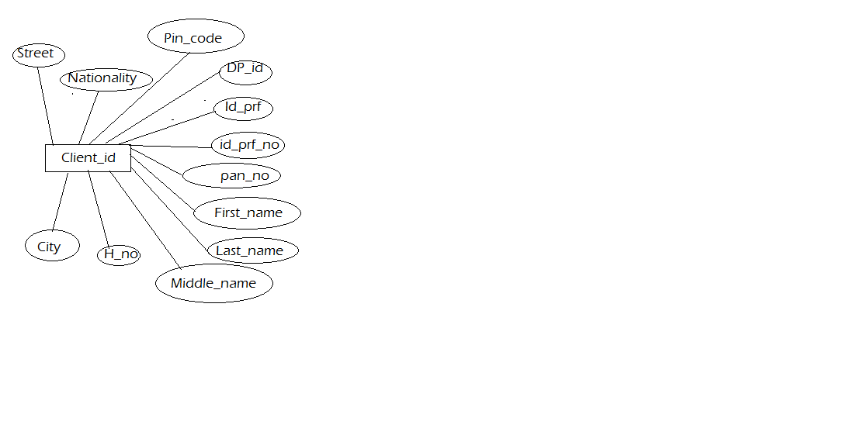

It is already in first n/f and ‘client_id’ functionally determines all other non-key attributes. Thus, it is in second n/f.

BC N/F:

It is in second n/f but id_prf_no and pan_no are also key attributes i.e. candidate key. Thus, we will make two new table: (Client_id, Pan_no) and (Client_id, id_prf_no)

**Pan: id_no:**

|  |  |
| --- | --- |
| Client_id | Pan_no |
|  |  |

|  |  |
| --- | --- |
| Client_id | Id_prf_no |
|  |  |

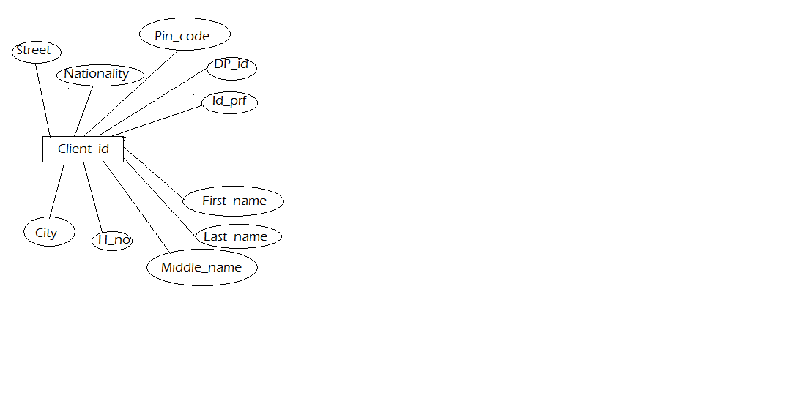

Third N/F:

It is already in second n/f and there is no transitive edge. Thus, it is in third n/f

Fourth N/F:

It is already in third n/f and there is no multi value dependency, thus, it is in fourth n/f.

Fifth N/F:

It is in fourth n/f abd can’t be decomposed any further into smaller tables, thus, is in fifth n/f.

**COMPANY:**

|  |  |  |
| --- | --- | --- |
| Code | C_name | Id |
|  |  |  |

First N/F: It is already in first n/f as each row and column combination will have at least one value.

Second N/F:

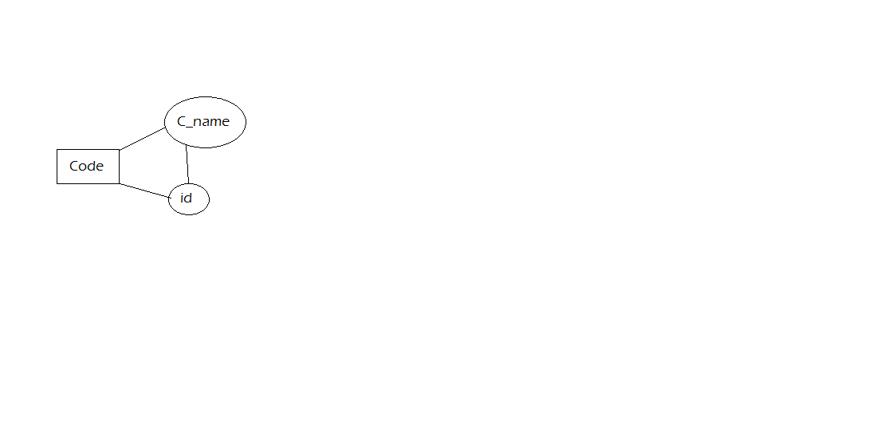

It is already in first n/f and in second n/f as ‘code’ functionally determines ‘c_name’ and ‘id’.

Third N/F: It is in second n/f but not in third n/f as there is a transitive edge. So, we will make new tables: (code, c_name) and (id, c_name). Now, it is in third n/f.

**Company_code: Company_id:**

|  |  |
| --- | --- |
| Code | C_name |
|  |  |

|  |  |
| --- | --- |
| id | C_name |
|  |  |

BC N/F: It satisfies bc n/f as the non-key attribute which functionally determines key attribute is already in separate table

Fourth N/F: It is already in third n/f and there is no multi value dependency, thus, it is in fourth n/f.

Fifth N/F: It is in fourth n/f abd can’t be decomposed any further into smaller tables, thus, is in fifth n/f.

**DP:**

|  |  |  |
| --- | --- | --- |
| Dp_id | Dp_name | Depository |
|  |  |  |

First N/F: It is already in first n/f as each row and column combination will have at least one value.

Second N/F:

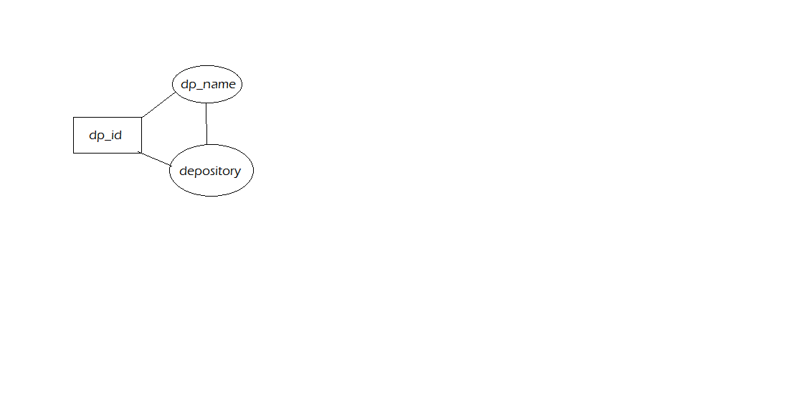

It is already in first n/f and in second n/f as ‘dp_id’ functionally determines ‘dp_name’ and ‘depository’.

Third N/F: It is in second n/f but not in third n/f as there is a transitive edge. So, we will make new table: (dp_name, depository). Now, it is in third n/f.

**Depository: DP:**

|  |  |
| --- | --- |
| Dp_name | Depository |
|  |  |

|  |  |
| --- | --- |
| Dp_name | DP_id |
|  |  |

These tables are selected as it is convenient to remember depository name than its id and find them.

BC N/F: It satisfies bc n/f as attribute which functionally determines pk is already in separate table.

Fourth N/F: It is already in third n/f and there is no multi value dependency, thus, it is in fourth n/f.

Fifth N/F: It is in fourth n/f abd can’t be decomposed any further into smaller tables, thus, is in fifth n/f.

After normalization, we have following tables:

TRANSACTION(t_id, client_id, code, date, time, type, buy_p, sell_p, qty);

TAX(client_id, bkg, s_tax);

CLIENT(client_id, dp_id, id_prf, first_name, middle_name, last_name, pin_code, nationality, city, street, h_no);

PAN(client_id, pan_no);

ID_NO(client_id, id_prf_no);

COMPANY_CODE(code, c_name);

COMPANY_ID(id, c_name);

DEPOSITORY(dp_name, depository);

DP(dp_name, dp_id);

PHONE(client_id, ph_no);

ACCOUNT(client_id, acc_no);

EMAIL_ID(client_id, email);

The tables: (client_id, code) and (client_id, dp_id) are dropped as information in these is already in TRANSACTION and CLIENT respectively.